**DAILY ONLINE ACTIVITIES SUMMARY**

|  |  |  |  |  |  |  |  |
| --- | --- | --- | --- | --- | --- | --- | --- |
| **Date:** | 16/06/2020 | | | | **Name:** | CHETHAN CK | |
| **Sem & Sec** | 4th SEM ‘A’ SEC | | | | **USN:** | 4AL18CS017 | |
| **Online Test Summary** | | | | | | | |
| **Subject** | | Complex Analysis, Probability and Statistical Methods(18MAT41) | | | | | |
| **Max. Marks** | | 30 | | **Score** | | 26 | |
| **Certification Course Summary** | | | | | | | |
| **Course** | Facial recognition using python | | | | | | |
| **Certificate Provider** | | | Udemy | **Duration** | | | 3 Hours |
| **Coding Challenges** | | | | | | | |
| **Problem Statement:** 1. Write a C Program to perform the following operations on Triply Linked List (TLL). | | | | | | | |
| **Status:** Completed | | | | | | | |
| **Uploaded the report in Github** | | | | YES | | | |
| **If yes Repository name** | | | | https://github.com/alvas-education-foundation/chethan_c_k | | | |
| **Uploaded the report in slack** | | | | YES | | | |

**Online Test Details:**

The online test was from module 1 which was about the calculus of complex function and construction of analytic function. There were 15 questions and the duration was 40 minutes. The questions were optimal and were easy. The score that I got in the test is 26/30.

**Snapshot:**

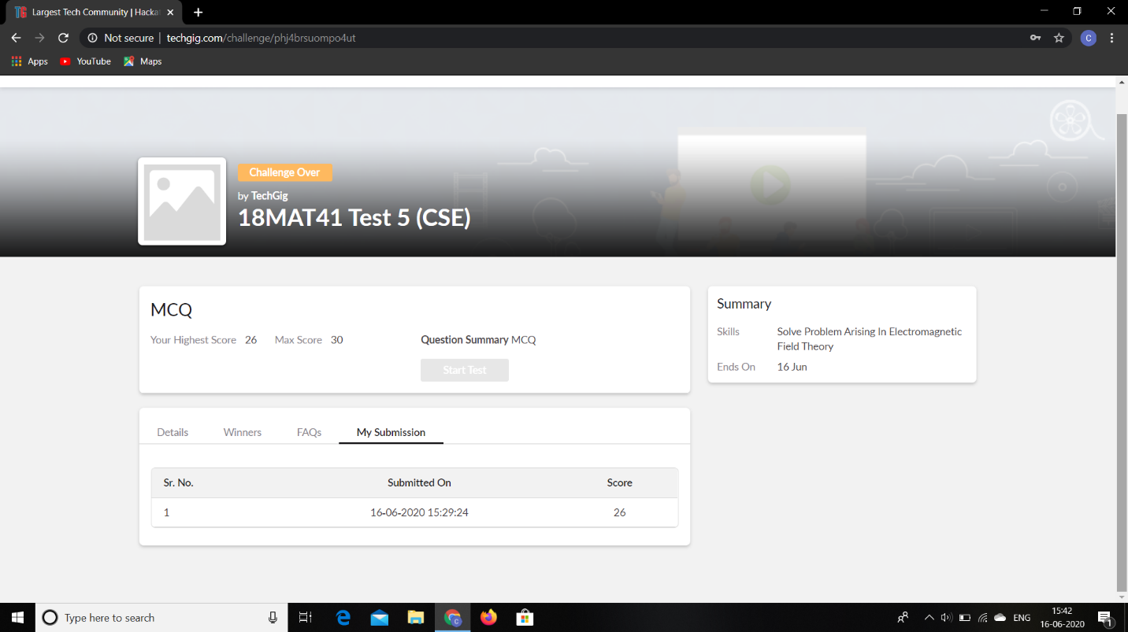

**Certification Course Details:**

**Name of the course**: Facial recognition using python

**Certificate Provider**: Udemy

Today I had learned about video face recognition.

**Snapshot:**

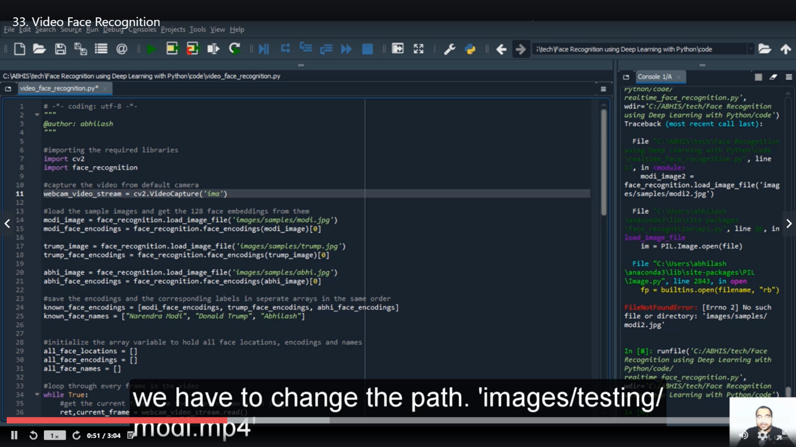

**Online Coding Details:**

Problem 1: Write a C Program to perform the following operations on Triply Linked List (TLL).

**Snapshot:**

